Amendments   
  
1. Recent activity  
+ The animation of recent activity need to be on the opposite  
+ the most recent user who inject need to appear on the top  
 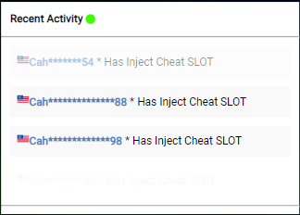  
  
2. Select cheat function  
+ Pilih cheat should be on “Select Cheat” Button  
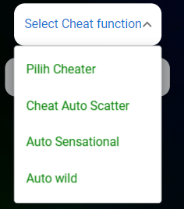  
  
  
3. Scanning animation

+ Wording not consistent  
+ We requested on the same animation like this website, the wording is just for reference   
+ <https://bobooljp.xyz/?fbclid=IwAR09y8aonSolcH2O7wtB3VfzSQ_lnnbbSNs93PPGVPzpQrcyJ7XcT0kn5TY>  
Add on Wording   
+ Connecting to B88 server  
+ Connecting to [Provider] server  
  
+ Attempts randomized from time to time  
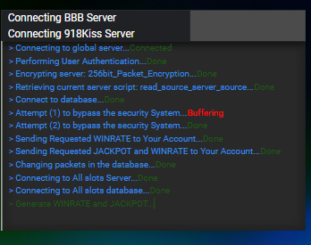  
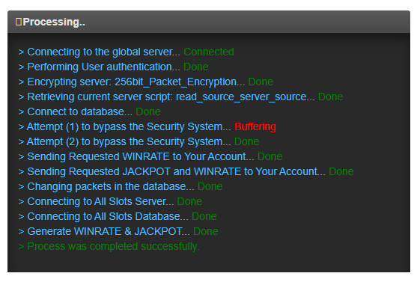  
  
  
  
4. Win rate of games appearance   
+ it should be wording, not using image cropped out  
+ use back white wording will do   
  
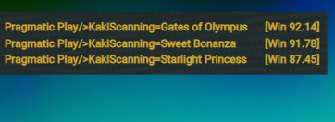  
  
5. Wording amendments   
+ “Cheatdigunakan” need to be changed to Cheat digunakan  
+ Penipuan change to Scanner   
+ add wording below “Copyright ©KakiScanner, all rights reserved 18+.”  
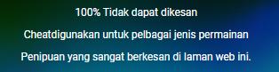  
  
6. Top 5 Games   
+ Top 5 games need to be remained for the entire day  
+ from our viewing, it changes every time when we refresh